**What 3D Printing Might Teach Us About Fabricating Truths**

**INKE Lightening Talk Paper – Social Knowledge Creation in the Humanities (DHSI)David N. Wright, Douglas CollegeMay 8, 2015**

This brief discussion paper confronts the following general question: if we are attempting to revive erased spaces by re-fabricating them, what responsibility do we have to the corpse’s social, political, economic, and cultural aura? Put another way, how should we consider, integrate or confront an individual—or collective—emotional effect produced by the revival of the previously erased or inert? Focusing on 3D printing and its inter-related communities of production, I want to look at how the production of material objects by 3D printing mediates the transaction of cultural artifacts. Suffice to say, there is a considerable space for understanding the current rush to fabricate as encouraging unforeseen fractures in (and connections to) the exchange and signification of cultural artifacts.

**The Filament**

The reproduction of erased spaces—loosely defined as demolished buildings, destroyed geographic features, lost/stolen objects, artifactual objects—is infiltrated upon by the plasticity of their fabrication. By re-producing erased objects using materials sometimes not even present in the original contexts, our re-fabrication creates a distorted sense of materiality. Even when the materials are the same—the reproduction in the same material as the erased original—the individual or collective reaction to the fabricated materiality suggests a fracture or obtuse connection to the original, erased, object. We do not account for the fabrication of materiality, as it is manifest through an individual or collective expectation. The filament that joins the 3D printed object to its community—both as cultural owners and as fabricators—is broken by consistent failures, errors or flaws in processing, and the rigidity of fabrication material choices.

The fiction of a 3D printed object—and I’m just going to claim that object as text to get us through the mire—is that its materiality signifies the success of the end product, rather than the signification of the object itself; successful fabrication alone is enough. Unlike the temporal reality of a novel, the fabricated object carries with it a different kind of cultural synthesis. It is at once “real”—tangible, spatial, manipulatable—and “unreal”—fabricated, plastic, dyed. The object tends to signify the success of the fabrication itself, rather than the representation or symbolic effect of its re-making or its reintroduction into cultural exchange. It’s as if the author were to suddenly declare, holding up something that looks like a historical novel: “Look, I made this book!” without ever addressing the content, its possible significance or its role as a potential cultural artifact.

Add to this that, as with the novel, the 3D printed object is separated from the politics of its making; the line that connects the object to its original cultural moment is thick with socio-cultural implications not addressed through the reproduction of the object itself. As we’ll see in a moment, rendering objects in plastic infects that object with a fabrication infrastructure completely disconnected from any significations its cultural capital might offer. Often amazed by the process of fabrication itself, we tend to avoid asking where the fabrication materials are coming from and how they might signify precisely the disenfranchised group that was once in possession of the original object.

Taking this filament linking the completed object to the politics of its revival into account then, it seems reasonable to suggest that 3D printing is fabricating—and I am using this term in the loaded sense, with all its possible definitions—more than the object itself. What 3D printing does is fabricate—again, in the loaded meaning sense—new cultural cross-references embedded in the tactility of the object it revives, reproduces, or oddly, erases even further—making stone into plastic.

**Fit to Scale**

While it is certainly possible to fabricate lost spaces at the original scale, it’s not common practice. Frequently, our equipment does not allow for accurate scale or the cultural fragments we use to help re-make erased spaces force us to guess at the size of the original. That said, the question of scale is particularly salient when we encounter large-scale reproductions. Take for example the reproduction of the square mile erased by the 9/11 attacks on New York City (Sacchetta):

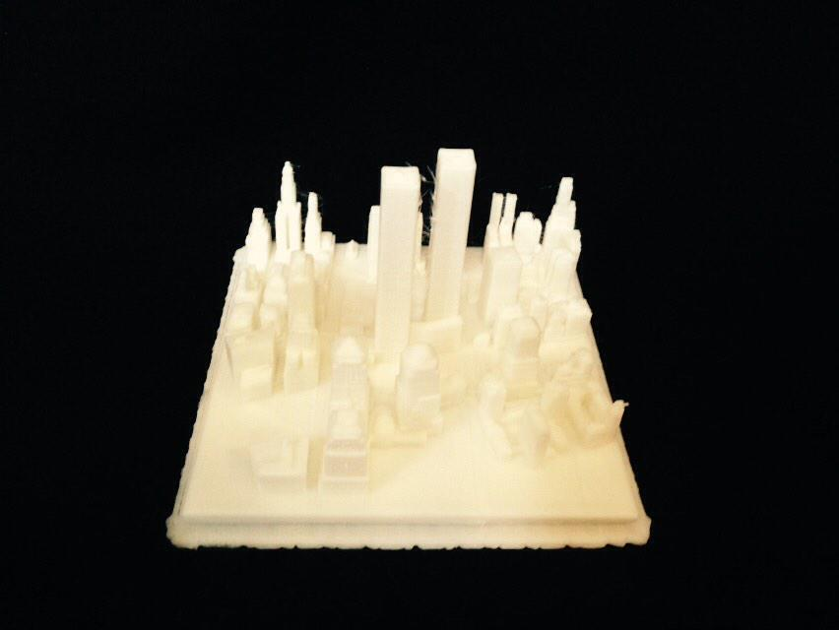

While it would be awesome to recreate the buildings at scale, reminding everyone of the ideal simulacrum, we need to play to the limits of our machinery. The recreation of lost surfaces such as these raises questions about socio-cultural resonance.

For instance, does something produced in miniature possess a resonance congruent with the original, and does this matter? Our experiences with 3D printing suggest that not only does scale affect the interpretation of the fabricated object, sometimes rendering once-erased objects in miniature performs a reductive act upon the social, cultural, economic, political offence all over again; creating a second erasure that at once acknowledges the lie—or fabrication—of the 3D printed object’s resonance, and ends up as a reductive commentary on the nuances of the original erasure. One gets a very clear sense of the problems raised by fabrication technologies when the objects to be reproduced become uncomfortable.

At the same time, thinking about scale forces us to confront more serious questions about motivation. Enthused with the potentialities of the emerging technology, we rush to “see if it’ll print” or “scale it to fit” the machinery to which we have access. When we fabricate things based on an incomplete sense of scale or reduce the scale of erased spaces to make them manageable, we necessarily set off another sequence of socio-political signifiers such as those raised by the plasticity of their fabrication. In short, we discard the potential reductive effect of the erased space’s very absence in favour of a defense that heralds its revival. Animating the very privilege that facilitates the fabrication itself, the reproduced object revives a host of emotional, cultural, social, political, even economic, signifiers. When we fabricate using 3D printing technologies, it’s very hard to avoid rendering erased cultural spaces, the cultural production associated with those spaces, and the emotional reaction they might illicit, as trinkets.

**The Tyranny of Error**

Largely determined outside the parameters of the 3D printer itself, scale and materiality are rendered moot by the tyranny of error brought on by the use of the hardware and software required to produce the object. Source files are corrupt, the software used to make those files sometimes dubious, and the printing machines themselves are prone to misalignment, failure, or technical misreadings. As the still nascent activity of desktop 3D printing—along with other forms of desktop fabrication such as laser cutters and millers for that matter—finds legs, the practices and principles that guide fabrication are born out of a community of hobbyists or transient professionals. As a result, there is little in the way of quality control beyond the community of practice, which does not yet fully account for the potential signification that errors in fabrication might yield.

Building on an acknowledgement of the effect error might have on the object’s cultural signification, material fabrication also needs to account for the permanence of the physical object that, once produced—even as an error or partial attempt—cannot accept changes or show the marginalia/evidence of its transformations. This is particularly important given that most reconstitutions of erased spaces tend to look for sources in the margins of society—those neglected, historical, erased, highly isolated, prototypes (or silences)—where little remains to mark cultural, economic, and aesthetic contexts.

The object in the photo below, printed using the Makerbot infrastructure—on-line community (Thingiverse), software, and 3D printing machine—illustrates some of the potential issues raised by a community of practice focused on the dissemination of the source file and success of the object’s rendering rather than the object’s cultural resonance. The process begins by loading the community-made .stl file of the *Taiwanese Aboriginal Harvest Festival Altar* (NANCHI) into the Makerbot preparation software.

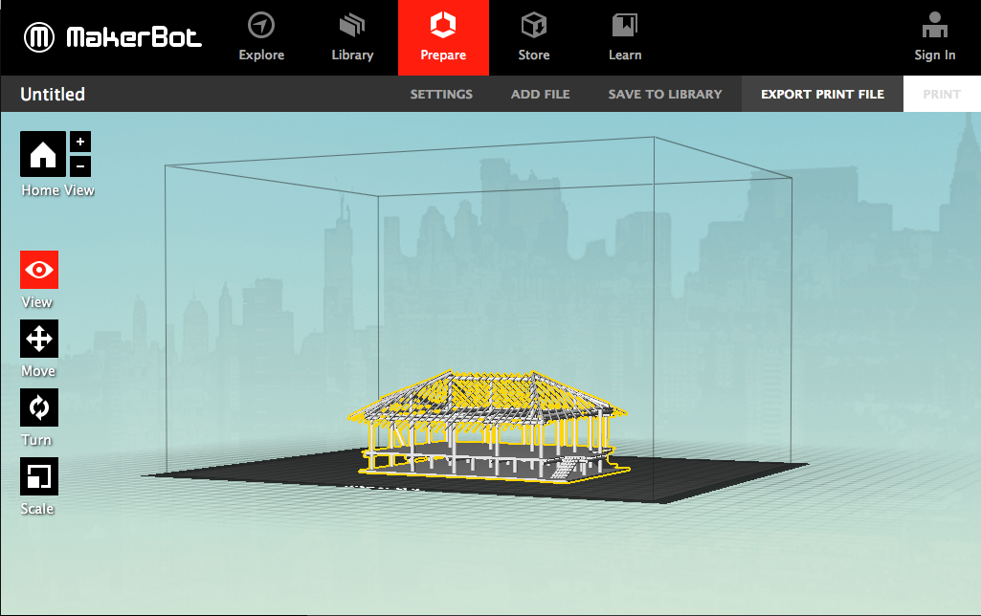

In this pre-fabrication environment, the Altar is already going through transformations that could be construed as manipulating its cultural place. The Altar is foregrounded in the on-screen interface in an urbanized environment that, though darkened, boxes or colonizes the object in a state that re-animates the process of cultural erasure. While no doubt designed to signal the community that created the file in the first place, the software interface places the indigenous object about to be fabricated within an urban, Westernized, capitalistic enclave, performing colonial erasure and context burning yet again, allowing a community of unknown motivations to manipulate and process the cultural artifact.

The next step in the fabrication process involves the actual printing of the object using plastic filament; the object is at the mercy of the machine’s tendencies.

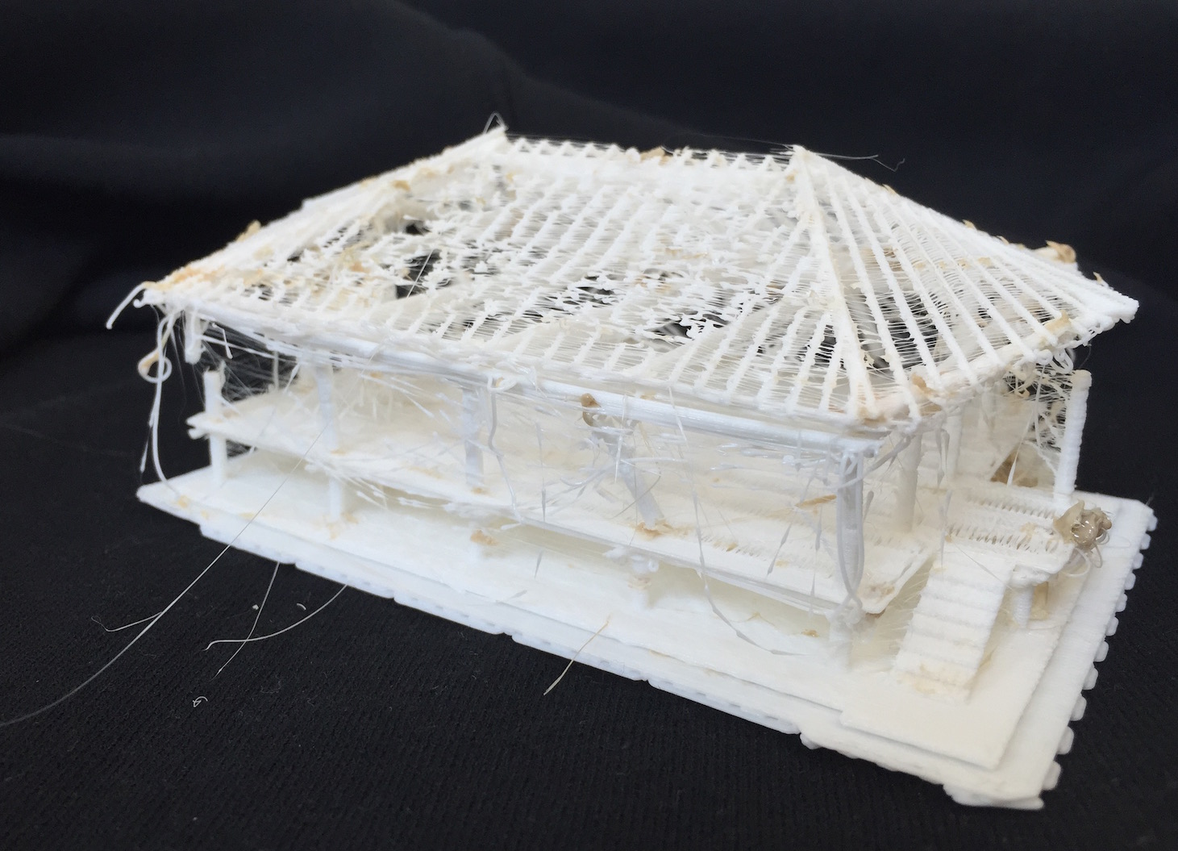

At this point, one must ask what effect the fabricated object has on the cultural truths the Altar might signify. The individual or collective reaction to the materiality of once-erased spaces intercedes upon the intended outcomes, rendering any knowledge creation or production inert. That is, while we may be able to fabricate erased objects—in this case using the *Taiwanese Aboriginal Harvest Festival Altar* as a representative example—we do not yet have a foundation for understanding and predicting triggers—be they cultural, social, economic—the reproduction of those models may elicit. We may be guilty, in our technologically-crazed zeal for the socialization of knowledge, of fabricating connections between materiality and memory, unduly activating difficult emotional reactions that are not accounted for in the value proposition for re-making erased spaces, which is about re-establishing erased truths and representing lost heritage.

With its flat colour, trailing spindles, lopsided planks, and buttered edges, the 3D printed Altar above shows the many layers of its fabrication that cannot be peeled back. The errors visible, the object becomes a bastardized fabrication of the original, forever rendered in plastic. The fabrication has not melted seamlessly, blending the layers into one another, creating the perception of smoothness, refinement, and completion. Instead, the hardware—and the process that governs its use—scans, renders, and finally fabricates erased spaces, representing a re-colonization rather than a renewed existence—one that is set off by the errors inherent in the object final state. The ugly fabricated Altar makes the cultural truths the object is trying to preserve subject to perversion, forcing us to ask: “What kind of reproduction is this? What are we fabricating: exploitation, destruction, displacement?”

Indeed, what is it we are fabricating exactly? Hint: it isn’t the object. It’s the idea that the object *doesn’t* signify the act of production itself (in the Fordian sense). The objects we reproduce fabricate the myth of permanence, preservation, and success rather than the political, cultural, and social values the object might represent; you can have any *Taiwanese Aboriginal Harvest Festival Altar* you want, as long as it’s white.

The very act of reproduction opens many questions from those groups who might claim ownership over the fabricated object itself. This includes the group who might “own” the original artifact, but also extends to the community that creates the source files, the community that builds upon it, revises it, and makes still more copies of it. The artifact represents a form of social knowledge creation—or dissemination—and as such carries with it the expectations, biases, and failures of the communities that fabricate it.

What the fabrication of erased spaces, as a form of technologically based social knowledge creation, might show us is that these spaces are not artifacts in a tactile or material sense, but rather are symbolic of a set of emotional, cultural, and economic realities that individuals and collectives may not be equipped to process. As we fabricate, or re-fabricate, assemblages of once-erased cultural spaces, what exactly are we activating in the social space and how might we account for the “fixed” truth fabricated by the 3D printing machine?

References:

*Old World Trade Center Site*. Sacchetta. February 22, 2015: <http://www.thingiverse.com/thing:693972>

*Taiwan Aboriginal, Aboriginal Harvest Festival Altar*. NANCHI. June 2, 2014: <http://www.thingiverse.com/thing:217653>